

Foundations of Programming

Assignment No.: 16
PROBLEM STATEMENT: To accept a list of N integers and partition the list into two sublists containing even and odd numbers.

OBJECTIVE:

- To understand how to work with arrays in C.
- To learn how to separate numbers based on conditions.
- To practice the use of loops and conditional statements.
- To display two different lists for even and odd numbers.

THEORY:
In C programming, arrays are used to store multiple values of the same data type. By using loops and conditional statements, it is possible to examine each element in the array and classify it based on certain conditions. In this program, the user enters N integers which are stored in an array. Each number is then checked using the modulus operator (%). If a number is divisible by 2, it is categorized as an even number; otherwise, it is an odd number. The program then displays two separate lists: one for even numbers and another for odd numbers.

PLATFORM: Linux
CODE:
#include <stdio.h>

int main() {
int n, i;
int evenCount = 0, oddCount = 0;

// Ask the user for the number of elements
printf("Enter the number of elements (N): ");
scanf("%d", &n);

// Declare the main array and two sublists
// The sublists are sized 'n' to safely accommodate cases where all numbers are even or all are odd
int arr[n], even[n], odd[n];

printf("Enter %d integers:\n", n);
for (i = 0; i < n; i++) {
scanf("%d", &arr[i]);

// Partitioning logic: Check if the number is perfectly divisible by 2
if (arr[i] % 2 == 0) {
even[evenCount] = arr[i];
evenCount++;
} else {
odd[oddCount] = arr[i];
oddCount++;
}
}

// Print the Even sublist
printf("\n--- Even Numbers Sublist ---\n");
if (evenCount == 0) {
printf("No even numbers found.\n");
} else {
for (i = 0; i < evenCount; i++) {
printf("%d ", even[i]);
}
printf("\n");
}

// Print the Odd sublist
printf("\n--- Odd Numbers Sublist ---\n");
if (oddCount == 0) {
printf("No odd numbers found.\n");
} else {
for (i = 0; i < oddCount; i++) {
printf("%d ", odd[i]);
}
printf("\n");
}

return 0;
}

INPUT AND OUTPUT:
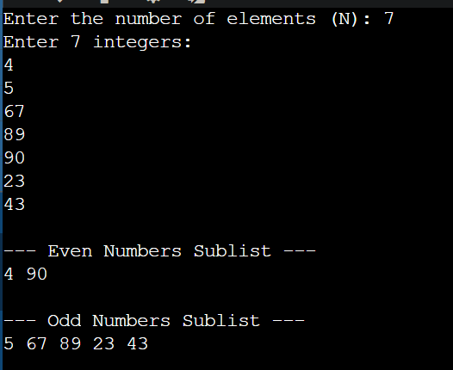

CONCLUSION: Thus, the C program successfully accepts a list of integers and partitions them into two separate lists of even and odd numbers.

